PROJECT DESIGN PHASE II

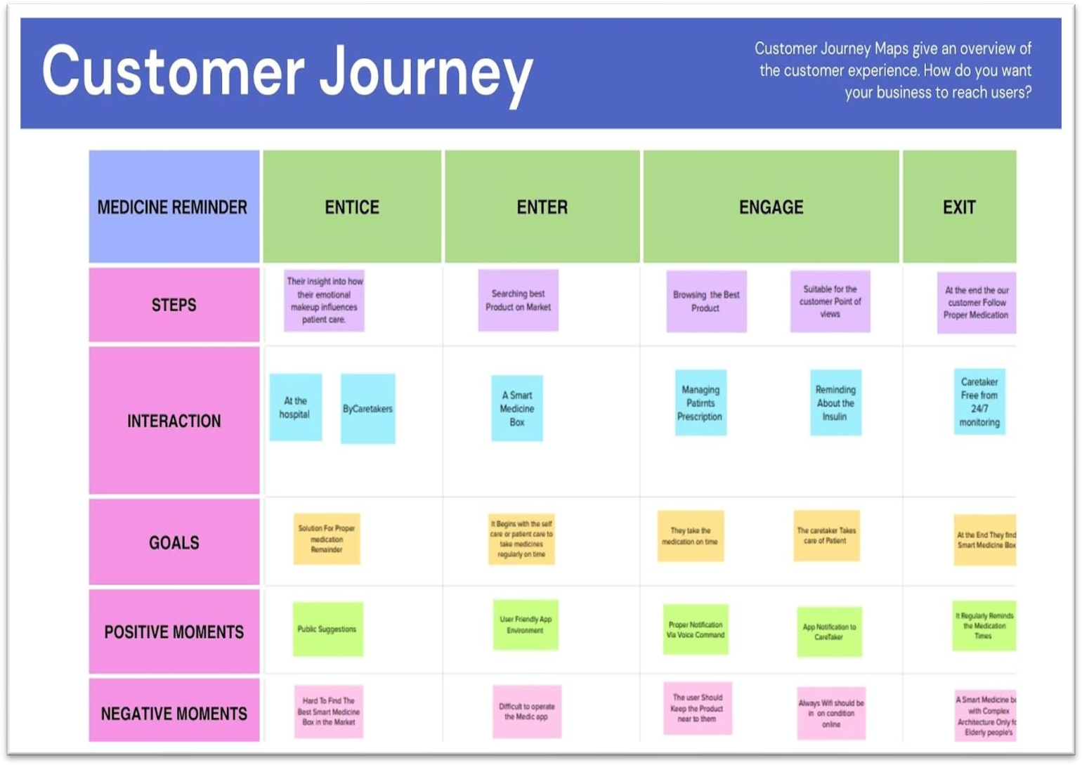

CUSTOMER JOURNEY

CUSTOMER JOURNEY MAP

|  |  |
| --- | --- |
| DATE | 25OCTOBER 2022 |
| TEAM ID | PNT2022TMID19437 |
| PROJECT NAME | PERSONAL ASSISTANCE FOR SENIORS WHO ARE SELF- RELIANT |